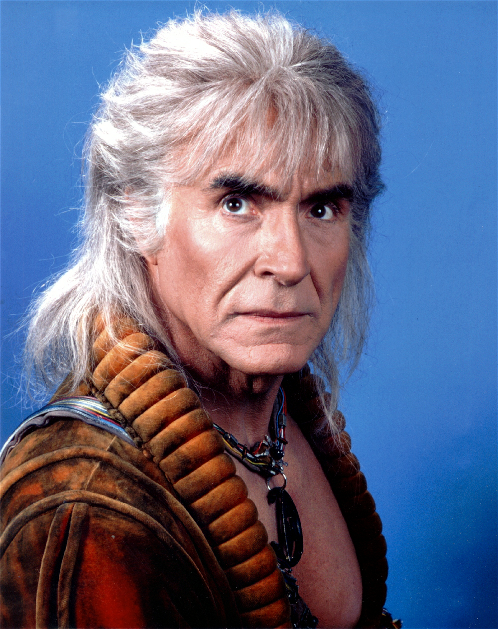A.P. U.S. Government Students: Khan Noonien Singh is now our inspiration. He gives us our new mantra:

“April 24th you say. It tasks me! It tasks me, and I shall have it! I'll chase it round the Moons of Nibia, and round the Antares Maelstrom, and round Perdition's flames before I give it up!”

The Executive Branch

- Structure of the Executive Branch:
- President and Vice President (also president of Senate whose main function is to break tie votes in the Senate).
- White House Chief of Staff (arguably the most powerful and influential position in under the president, often more so than the Vice-president; president appoints but no advice and consent needed form the Senate; the Chief of Staff makes sure everyone is doing his/her job in the executive branch; the president’s MOST frank and trusted advisor…VERY close to the president).
- Press Secretary: conduit of information from the president to the press/public; holds press conferences with reporters from major news outlets to explain the president’s views/policies as well as putting a positive “spin” on negative press about the president.
- Executive Office of the President: a collection of groups of advisers to the president; created by FDR because of the HUGE growth of presidential power and responsibility in the 20th century.
Major components pf the Executive Office of the President are:
-The NSC (National Security Council): group of advisors to the president, who give him information/advice on military affairs and foreign affairs
-Council of Economic Advisors: group of advisors to the president, who give him information/advice on economic affairs
-Office of Management and Budget (OMB): prepares the president’s budget for the government, which he/she will submit to Congress

- Bureaucracy: helps the president implement the laws made by Congress. The bureaucracy is comprised of 15 cabinet departments and the “alphabet agencies” . See the diagram below.
(E.g. Cabinet departments: Department of Education, Department of Justice, etc. and agency examples would be: EPA= Environmental protection Agency; FCC=Federal Communications Commission; FDA= Food and Drug Administration; FTC= Federal Trade Commission)

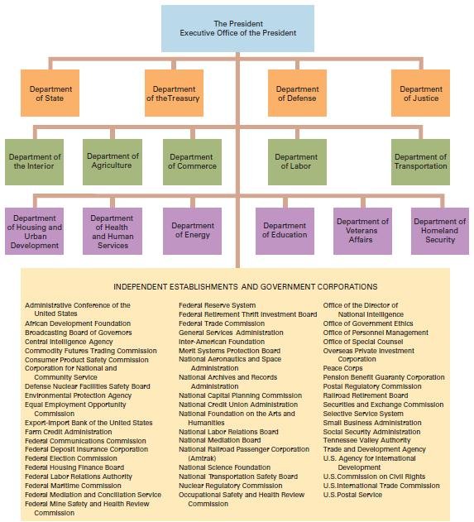

- How is a preesident elected?

“Electoral College” A system for electing the president. In this system Americans really vote for people called electors. The electors then vote for the president.

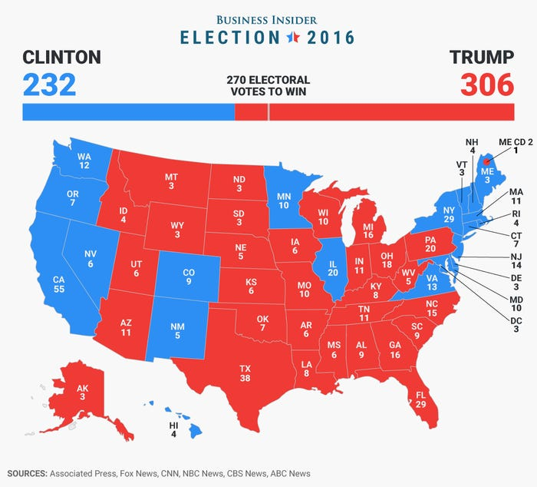

2016

 |  | Candidate | Party | Electoral Votes | Popular Votes
 |  | Donald J. Trump (R) | Republican | 304 | 62,980,160
 |  | Hillary R. Clinton (D) | Democratic | 227 | 65,845,063
 |  | Evan McMullin (IND) | Independent | 0 | 728,830
 |  | Gary Johnson (L) | Libertarian | 0 | 4,488,931
 |  | Jill Stein (G) | Green | 0 | 1,457,050

2016 Election Facts

Issues of the Day: Health care costs, Economic inequality, Terrorism, Foreign policy (Russia, Iran, Syria, Brexit), Gun control, treatment of minorities, and immigration.

Fun facts:
- One of only 5 elections (1824, 1876, 1888, 2000, 2016) where the popular vote winner was defeated
- Hillary Clinton first female presidential nominee of a major political party
- Clinton won Maine but Trump earned an electoral vote by winning the popular vote in the 2nd Congressional District. This marked the first time that Maine has split its electoral vote since it moved away from the winner-take-all method in 1972.
- Independent Evan McMullin received 21.5% of the vote in Utah; best '3rd party' performance in any single state since Ross Perot in 1992
- Libertarian Gary Johnson received over 3% of the nationwide vote; best 3rd party performance nationwide since Ross Perot in 1996
- There were seven faithless presidential electors. Aside from 1872 - death of Horace Greeley - it is the greatest number since electors began casting one vote each for president and vice president (12th Amendment, 1804). Three additional faithless votes, one each in Colorado, Maine and Minnesota, were disallowed.
- Clinton won Washington; however three electors cast votes for Colin Powell, one for Faith Spotted Eagle
- Trump won Texas; however one elector cast a vote for Ron Paul, another for John Kasich
- Clinton won Hawaii; however one elector cast a vote for Bernie Sanders

-There are 538 electoral votes (435 correlating to the number of members of the House, 100 correlating to the number of senators in the Senate, and 3 for washington, D.C.). How many U.S. Congressional Districts are on the map below?

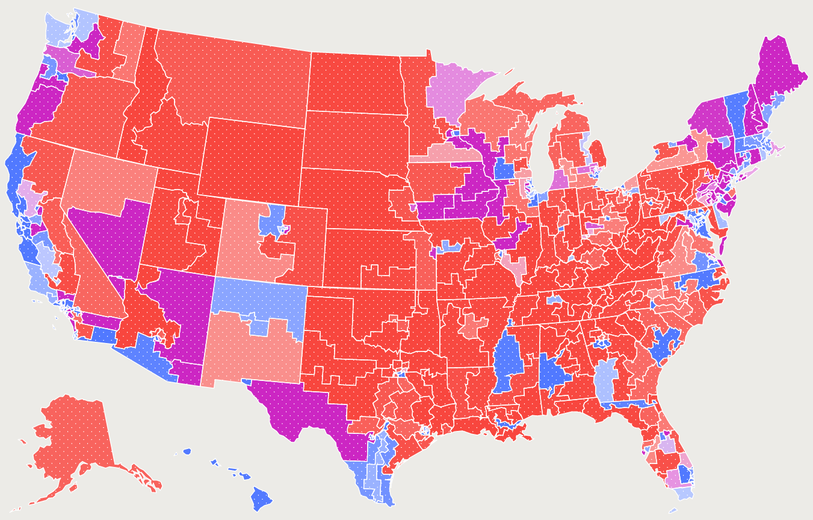

***To win the election for President a candidate must get a majority of electoral votes, so he/she must win __________________ electoral votes to win the election.

*****Q: What happens if the presidential candidates get a tie in the electoral
vote? How do we know who becomes President?

How the Electoral College Works:

-Popular vote: the total votes from the citizens of the U.S. (i.e. the people)

-Electoral vote: votes from electors in the Electoral College

-Americans don’t vote directly for a candidate.
-Americans really vote for a group of electors who are pledged (i.e. promised) to one of the Presidential candidates.
-the number of electors in each state is equal to the number of Representatives plus the number of Senators from that state.
- in almost all the states the candidate that gets the most popular votes in a state gets all the electors from that state (this is known as the “winner take all” system);

EXCEPTIONS to Winner-Take-All ARE:

Although it is possible for an Elector to cast his or her vote for someone other than for the popular vote winner in their state (and be a “faithless elector”), this is quite rare in modern times. As a result, Electoral Votes for a state tend to be "all or nothing".

Maine and Nebraska have taken a slightly different approach in recent years (proportional voting). These states allocate two Electoral Votes to the popular vote winner, and then one each to the popular vote winner in each Congressional district (2 in Maine, 3 in Nebraska) in their state. This creates multiple popular vote contests in these states, which could lead to a split Electoral Vote.

-It is possible for a candidate to win the “popular vote”, but not win the most electoral votes.
-SO even though a candidate wins the popular vote, he can lose the election if he doesn’t win the electoral vote.

Sooooo If neither candidate gets a majority of the Electoral Votes, the election for President is decided in the House of Representatives, with each state delegation having one vote. Senators would elect the Vice-President.
-Tennessee has 11 electoral votes.

Problem with Electoral College’ winner-take-all system: Someone can win 49% of the popular vote in a state and win none of its electors! Two proposed constitutional amendments for making the winner-take-all system fairer: create a proportional system OR abolish the E.C. altogether and allow the president to be determined by the popular vote, requiring that a candidate win at least a 40% minimum of the popular vote in order to win the election or a run-off election between the top two candidates would be needed.

Split-ticket voting refers to when a voter in an election votes for candidates from different political parties when multiple offices are being decided by a single election (e.g. a citizen can vote for a presidential candidate that is in the Democratic party and then vote for a U.S. Senator in the Republican Party, etc.).

Split-ticket voting contrasts with straight-ticket voting, in which a voter chooses candidates from the same political party for every office up for election.

“270 to Win” web site with election results:
https://www.270towin.com/historical-presidential-elections/

- Presidential Powers: The American Presidency has changed dramatically over American history. It has become more and more powerful as the Congress has ceded power. Why?

Intro: Beginning with our first president, George Washington, many presidents have used their implied and informal presidential powers to enhance their personal influence, and often the power and potential influence of later presidents. Many of these implied powers which are assumed as granted under the Constitution although not explicitly listed, stem from a president's responsibilities during times of national emergency. For example, our early presidents, including Washington and Jefferson, didn't hesitate to exercise their commander-in-chief authority by ordering Navy ships into hostile waters without an express declaration of war from Congress. And in his bold Louisiana Purchase, Jefferson showed that a president who acts decisively might successfully compel others to follow his lead after the fact.
A president's informal powers, or the powers to persuade others to follow his lead, derive in part from his use of the visibility and prestige of the office itself. As America's only nationally elected leader, the president is considered our county's "first citizen" who stands and acts for the American people as a whole. Some presidents, such as Lincoln, Wilson, Theodore Roosevelt, and Franklin Roosevelt, drew upon their informal powers during times of national crisis to increase their influence over others in Congress and the executive branch. Other presidents, including Lyndon Johnson, drew upon their personal skills and intimate knowledge of legislative processes to pass bold national initiatives such as the Civil and Voting Rights Acts.
During the twentieth century, the presidency itself was transformed. As they presided over two world wars, a major depression, and a cold war, several twentieth century presidents increased their powers and influence at the cost of Congress and other government institutions. Presidents now compete with Congress in setting and enacting the country's legislative agenda, and the White House is the focal point for setting foreign and domestic policy. Presidents Nixon, Reagan, and Clinton, for example, conducted specific foreign policy initiatives almost wholly from within the White House, sometimes at the cost of a consistent and unified U.S. foreign policy.

Section 2 - Civilian Power over Military, Cabinet, Pardon Power, Appointments
“The President shall be Commander in Chief of the Army and Navy of the United States,
and of the Militia of the several States……. and he shall have Power to Grant Reprieves and Pardons for Offenses against the United States, except in Cases of Impeachment…
He shall have Power, by and with the Advice and Consent of the Senate, to make
Treaties, provided two thirds of the Senators present concur; and he shall nominate, and
by and with the Advice and Consent of the Senate, shall appoint Ambassadors, other
public Ministers and Consuls, Judges of the supreme Court, and all other Officers of the
United States whose Appointments are not herein otherwise provided.” ….
Teacher Note follows here: (Appoints cabinet secretaries BUT the Congress creates new departments in the cabinet. The only original cabinet departments that George Washington had were the Department of War (now Dept. of Defense), Department of the Treasury, and the Department of State.

Section 3 - State of the Union, Convening Congress
“He shall from time to time give to the Congress Information of the State of the Union…(a formal power)

A. Formal Powers (A.K.A. explicit, expressed, or enumerated) that are listed in Article II sections 2 and 3 of the U.S. Constitution…see text above):
-civilian Commander-in-Chief of all American armed forces
-power to issue pardons (order to let someone out of jail and wipes crime from person’s record) and reprieves (order to let someone out of jail but the crime stays on the person’s permanent record).
-makes treaties with foreign country with advice and consent (i.e. approval) of Senate, with a super majority vote (i.e. at least 2/3 vote).
-nominates ambassadors, heads of cabinet departments(i.e. “Secretary of”) in the executive branch’s bureaucracy and federal judges (including SCOTUS justices, of course) with advice and consent of the Senate (simple majority vote for approval). Remember tough that Congress creates new cabinet departments…Department of Homeland Security is the most recent one.
-“state of the union” address: annual speech before Congress, SOTUS, heads of armed forces, etc. in which s/he details what important events/policies have occurred in the past year and what policies s/he will focus on in the future.
-veto power over Congressional legislation
-“pocket veto” (actually enumerated in Article I): if Congress passes a bill, the president has 10 days to sign it. If s/he does not sign it within the 10 day period and the Congress is NOT in session (i.e. Congress has adjourned), then the bill is vetoed, i.e. does not become a law….IF the President does not sign it within the 10 day period and the Congress is IN session, then the bill automatically becomes a law.

B. Implied powers: Implied are those powers that Congress and the president need in order to get the job done right. Although not specified in the Constitution, they are reasonable powers that are a logical part of the powers delegated to the president. Examples of implied powers are: executive orders, executive privilege, and executive agreements. The president’s implied powers are derived from the following two clauses in Article II:

The executive Power shall be vested in a President of the United States of America.” (source of implied powers)

AND

“he shall take care that the laws be faithfully executed” (source of implied powers)

Executive orders are one type of implied power that the president has. Executive orders are orders made by the president that though they are not law have the force of law. Like laws, executive orders can be ruled unconstitutional by SCOTUS. Frequently the executive orders of one president are in effect overturned when a new president comes in and creates executive orders that countermand the ones made by his/her predecessor. Prime examples of executive orders are Lincoln’s Emancipation Proclamation and Franklin D. Roosevelt’s executive order to imprison Japanese Americans during WWII.

Executive Privilege is another implied power of the president. This power gives him the authority to withhold information form other branches of government and the American people as a form of private communication that allows him to get honest advice form his advisors, without the threat of embarrassment or retaliation to those advisors.

Executive Agreement: an implied power that is an agreement that a president makes with another country that does not require the U.S. Senate to give 2/3 approval like a treaty would.

- Other powers:

Line-item veto:
In the United States government, the line-item veto is the right of the chief executive to nullify or cancel individual provisions in bills—usually budget appropriations bills—without vetoing the entire bill. Like regular vetoes, line-item vetoes are usually subject to the possibility of being overridden by the legislative body. While many state governors have line-item veto power, the President of the United States does not.
The line item veto is exactly what you might do when your grocery tab runs to $20.00, but you only have $15.00 on you. Instead of adding to your total debt by paying with a credit card, you put back $5.00 worth of items you don’t really need. The line item veto — the power to not buy unneeded items — is some power U.S. presidents have long wanted but have just as long been denied.
President Clinton had use of the line-item veto for a short period of time before SCOTUS ruled it unconstitutional as it violated the “presentment clause” of the Constitution (i.e. a clause in the Constitution that gives Congress the sole power to send a complete bill to the president he can either sign or veto ). SCOTUS said if a president could pass part of a bill and veto other parts then he, in effect, had legislative power, a power that only Congress has.
Statutory powers:

powers given to the President by congressional statute (i.e. congressional law…statute, act, and law are synonyms). An example of a statutory power is the line-item veto for the president. The line-item veto is now unconstitutional. Since a statutory power for a president is written down, one could call it a formal power of the president as well.

Presidential Bill Signing Statements
A bill signing statement is an optional written directive issued by the President of the United States upon signing a bill into law. Signing statements typically begin with the phrase “This bill, which I have signed today…” and continue with a synopsis of the bill and several paragraphs of often-political commentary on how the bill should be enforced.
Some experts refer to presidential signing statements as being documents "in which the president signs a bill but also specifies which parts of a bill he or she actually intends to enforce." On the face of it, that sounds terrible. Why even have Congress go through the legislative process if presidents can unilaterally re-write the laws it enacts? Before flatly condemning them, there are some things you need to know about presidential signing statements. First, the president's legislative power to issue signing statements is based in Article II, Section 1 of the U.S. Constitution, which states that the president "shall take Care that the Laws be faithfully executed..." Signing statements are considered to be one way in which the president faithfully executes the laws passed by Congress. This interpretation is supported by the U.S. Supreme Court's which held that "... interpreting a law enacted by Congress to implement the legislative mandate is the very essence of 'execution' of the law."

Emergency powers:

The Constitution does not expressly grant the president additional powers in times of national emergency. However, many scholars think that the Framers implied these powers because the structural design of the Executive Branch enables it to act faster than the Legislative Branch. (NOTE on emergency powers: many powers now considered emergency powers are powers that Congress has allowed by statute over the last three or four decades…shame on Congress for being supine invertebrates!!!)
Some examples of emergency powers: Pres Bush closed airports and order fighter jets in the air when the U.S. was attacked on 9-11. Many presidents have order the national guard to states to help out after a natural disaster such as a hurricanes, tornadoes, and major forest fires.

D. Foreign Policy (powers to deal with foreign countries) and Domestic Policy (powers to deal with issues here in the good ol’ U.S. of A.

E. Limits on Presidential Power:

- 22nd Amendment: A president may only be elected 2 times (i.e. only person in the three branches that has term limits) …this amendment was created as a result of F.D.R.’s 4 terms as president.
- Article II, Section 1 “No person shall be elected to the office of the President more than twice, and no person who has held the office of President, or acted as President, for more than two years of a term to which some other person was elected President shall be elected to the office of President more than once”.

- War Powers Act:
The War Powers Act is a congressional resolution designed to limit the U.S. president’s ability to initiate or escalate military actions abroad. Among other restrictions, the law requires that presidents notify Congress after deploying the armed forces and limits how long units can remain engaged without congressional approval. Enacted in 1973 with the goal of avoiding another lengthy conflict such as the Vietnam War, its effectiveness has been repeatedly questioned throughout its history, and several presidents have been accused of failing to comply with its regulations.
The War Powers Act is a congressional resolution designed to limit the U.S. president’s ability to initiate or escalate military actions abroad. Among other restrictions, the law requires that presidents notify Congress after deploying the armed forces and limits how long units can remain engaged without congressional approval. Enacted in 1973 with the goal of avoiding another lengthy conflict such as the Vietnam War, its effectiveness has been repeatedly questioned throughout its history, and several presidents have been accused of failing to comply with its regulations.

- Impeachment: impeachment charges for “high crimes and misdemeanors” are voted on in the House (simple majority) and an impeachment trial on those charges would be held in the Senate; if the Senate convicts a president in the trial by a super majority (at least 2/3) then the president is removed from office AND is still subject to criminal charges in a U.S. court. Only presidents ever impeached: Andrew Johnson and Bill Clinton; only president ever to resign was Richard Nixon (over the “Watergate” scandal in which he tried to cover-up his role in some workers/advisors in his administration who broke into the Democratic Party’s office in the Watergate hotel to steal information that might help Nixon get elected; We’re still not sure if Nixon ordered the break-in or just tried to cover it up).

F) Quick Review of presidential powers
-vetoes: formal
-pocket vetoes: formal
- Commander-in Chief : formal (conducts foreign policy as the civilian Commander-in-Chief)
-state of the union: formal
-Executive agreements- implied
-Executive orders: implied
-Executive privilege: implied
-bargaining and persuasion: informal power that enables the president to secure congressional action or other things because by simple virtue of being the most powerful person on the planet, when s/he talks people listen!

IV. Another NOTE: the U.S., of course, has a federal republic government, AND it is also called a “presidential system”, which means the president holds the title/power as the ‘head of state” (a ceremonial role) and the head of government” (power to govern).

V) AND ANOTHER NOTE: Why the decrease in Congressional power and the increase in presidential power?

- The rise of partisanship is one important reason. Although foreign policy has never been fully isolated from politics, political polarization began to rise in the 1970s, and it increased sharply in the 1990s. Today, members of Congress reflexively support their own party. In periods of unified government, this means extreme deference to the president. In periods of divided government, it means congressional gridlock. Neither scenario yields much in terms of congressional oversight.

- Polarization also gives presidents reason to simply ignore Congress when making foreign policy. As the political scientist Kenneth Schultz has argued, with members less willing to cross the aisle, it is “more difficult to get bipartisan support for ambitious or risky undertakings, particularly the use of military force and the conclusion of treaties.” And so presidents opt for alternatives such as executive agreements over formal mechanisms such as ratified treaties. Consider the Iran nuclear deal. In 2015, President Barack Obama, concerned that he could not get a treaty with Iran past the Republican-controlled Congress, chose to make an executive agreement (which made it all too easy for Trump to tear up the deal later).

- Another trend that has sapped Congress’ influence is the decline of congressional expertise on foreign policy and national security. Simply put, legislators used to know more about foreign policy than they do now. Greater expertise strengthened Congress’ formal and visible role, since committees could engage in greater oversight of the executive branch. Expertise also reinforced Congress’ invisible means of constraining presidential power. Presidents had to think about how a seasoned committee chair or member would assess a policy. During his initial escalation of the Vietnam War, for example, President Lyndon Johnson was careful to maintain the support of powerful committee chairs, such as Senator J. William Fulbright, who led the Senate Foreign Relations Committee from 1959 to 1974. Fulbright shepherded the Gulf of Tonkin Resolution through the Senate in 1964, but two years later, his probative hearings helped shift public opinion against the war.

- Congressional expertise also led to serious, bipartisan policies that could force the president’s hand.

VI. Federalist 70:

Federalist 70 short synopsis: In this Federalist Paper, Alexander Hamilton argues for a strong executive leader, as provided for by the Constitution, as opposed to the weak executive under the Articles of Confederation. He asserts, “energy in the executive is the leading character in the definition of good government.

Selected salient excerpts from Federalist 70:
To the People of the State of New York:
THERE is an idea, which is not without its advocates, that a vigorous Executive is inconsistent with the genius of republican government. The enlightened well-wishers to this species of government must at least hope that the supposition is destitute of foundation; since they can never admit its truth, without at the same time admitting the condemnation of their own principles. Energy in the Executive is a leading character in the definition of good government. It is essential to the protection of the community against foreign attacks; it is not less essential to the steady administration of the laws; to the protection of property against those irregular and high-handed combinations which sometimes interrupt the ordinary course of justice; to the security of liberty against the enterprises and assaults of ambition, of faction, and of anarchy.
A feeble Executive implies a feeble execution of the government. A feeble execution is but another phrase for a bad execution; and a government ill executed, whatever it may be in theory, must be, in practice, a bad government.
Taking it for granted, therefore, that all men of sense will agree in the necessity of an energetic Executive, it will only remain to inquire, what are the ingredients which constitute this energy? How far can they be combined with those other ingredients which constitute safety in the republican sense? And how far does this combination characterize the plan which has been reported by the convention?

VII. Other important information regarding the President (POTUS) and the Executive Branch:
- Presidential reelections and midterm elections: The President’s party usually loses seats in Congress as his “honeymoon period” is now over (The honeymoon period is a metaphor that is used to compare the new president coming to power and his first few months with the honeymoon of a newly-married couple. Just as the newly-married couple are deeply in love with each other and can't find any fault in their partner, so the country trusts so much in the new president and in the promises that they made in their election campaign that they cut them a lot of slack in their first few months. It is a grace period when the president’s approval is high and he can get more legislation passed, before his inevitable decline in the polls).

- Presidential Approval Ratings: presidential approval ratings depend primarily upon two things: how the public perceives his/her performance on the economy and/or foreign policy.

- Divided Government: when the presidency is held by one of the major parties and the Congress is held/has a majority by the other major political party.

- Judicial Power of the President (sounds odd perhaps, but think about it): Pres can appoint Supreme Court Justices, as well as other federal judges. He can also grant pardons and reprieves. A pardon forgives the crime and frees the person from legal ties, while a reprieve is a postponement of a sentence. Appointments by President: presidents can change the “direction” of the Court (i.e. make it more liberal or conservative by nominating a judge who shares the president’s judicial philosophy and her positions on various public policies).

- The President’s “Hats”:
- Chief Diplomat: president as ambassador (ceremonial) or treaty negotiator (governing) with heads of foreign nations
- Chief Legislator: suggests legislation for Congress’s policy agenda; in this role the president helps to shape the Congressional agenda. An example would be Obamacare.
- Commander-in-Chief: civilian head of the military; the pres. is not a member of the military.
- Chief Executive: the president executes (i.e. carries out or enforces) the law…in our “presidential System” of democracy, the president serves as both ‘head of state” (ceremonial role) and “head of government” (governing/policy-making role).
*note: arguably, the president’s most important responsibility is the national security of the U.S.A. and the protection of the American people.

F. Checks and Balances 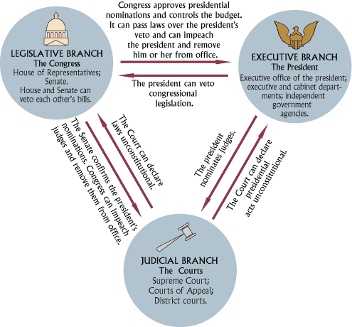
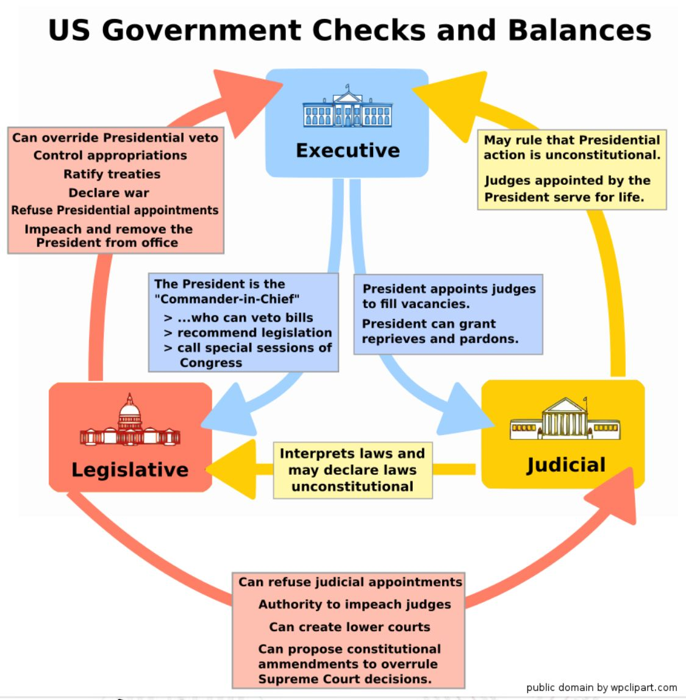

Top of Form

